Disclosure Document
Art Foundations 1
Emily Lamb, elamb@alpinedistrict.org
Website: lambartfoundations.weebly.com

Welcome to Art Foundations 1! I’m so excited to have you in my class this semester. I hope to get to know each and every one of you, and that we will be able to create some pieces of art you will be proud of.

What are we going to do in this class?
Art Foundations 1 - This is an introductory course offering instruction in a variety of art media, concentrating on basic concepts and principles of art. Each student will have the opportunity to develop a general knowledge and understanding of basic art terms, style, media, skills and techniques. Emphasis is on the student who has no previous drawing experience.

Basic Objectives - What will you have learned by the time you leave?
- Students will build a vocabulary suitable to discussing the visual arts.
- Students will explore the elements and principles of design in their artwork.
- Students will use a variety of material to create personal works of art.
- Students will solve visual problems enabling them to become more complex thinkers and problem solvers.

What do I expect of you?
- Students will be expected to attend regularly and be ON TIME. This is a participation-based class. This means a lot of your grade will depend on just showing up and working in class.
- Students are expected to be respectful to their classmates, respectful to me, the teacher, and be respectful to themselves.
- Students are expected to create their BEST work and be POSITIVE. Art is fun! Be happy, laugh, joke, but be kind.
- Don’t eat food in class. It can get on your and others’ projects!
- Read the board - I’ll put the objectives up there as well as due dates.
- If you make a mess, you CLEAN the mess. Art is a messy subject, and I will need all of you to help me keep our space organized and clean.
- Be ready to work, and don’t be too hard on yourself if you’re project doesn’t turn out how you wanted it to on the first try. You’re allowed to continually improve your work and your grade. No artist was ever perfect on their first try!

Late Policy, Attendance, and Class Participation:
- You get 5 points everyday for attending class, being prepared, staying on task, and exhibiting good behavior. I can take points away if I feel you aren’t doing these things. People who are tardy will need to go to room #29 so don’t be late! Plus points can be taken off for the warm-up sketches. Participation points can ONLY be made up for excused absences. See Ms. Lamb or the weebly for make-up work.
Grading:
- Grading will be based upon major projects, daily sketchbook warm-ups, individual progress, class participation, and tests or quizzes. A total points system for projects, assignments, and tests similar to the following will be used:

94-100% A 84-86% B 74-76% C 64-66% D
90-93% A- 80-83% B- 70-73% C- 60-63% D-
87-89% B+ 77-79% C+ 67-69% D+ 0-59% F

Late Work:
- Every class period after an assignment is due is -10%. This means you will lose 50% of the points off an assignment after 5 class periods of it being late. The only exception is filling out a late form BEFORE the assignment is due explaining why it will be late and your plan to complete it in a timely manner. I understand life can get crazy, so if you need to make up late points come and talk to me, and we can work something out.

Homework:
- Most assignments will be completed in class, however, there may be a few projects or assignments during the semester to be completed at home. Time outside of class is sometimes used by highly motivated students or by students who do not use class time wisely.

Class Policies:
- RULES TO LIVE BY: Take care of yourself. Take care of others. Take care of this place.

Discipline Policy:
- I expect students to be mature and self-motivated. If behavior is not appropriate, I will speak with the student privately about the issue. If the situation does not improve, parents will be contacted. If the problem persists, the student will be referred to the principal’s office for disciplinary action or removal from the class. Any damages to the classroom or supplies will be paid for by the student!

What do I need to bring to class?
- Bring yourself! And a pencil. Not a pen. A pencil.

Daily Sketchbooks:
- Every day when you come to class there will be a sketchbook prompt on the board. The first 10 minutes of every class period will be devoted to completing the prompt in your sketchbook (which I will provide for you and keep in class). Each prompt is worth 5 points. These can be made up!

Parents, I look forward to working with your students. I also look forward to working with you. Please sign below and include your e-mail address, or a daytime phone number so I can keep in contact with you about your student’s progress in my class. Also, please include any information about your student that may help me to help them to succeed in my class.

Thank you, Ms. Lamb

I have read and understand the above information.

Student Name:________________________________________________________________

Student Signature:_____________________________________________________________

Parent Name:_________________________________________________________________

Parent Signature:______________________________________________________________

Parent’s E-mail address/ Day Time phone:__________________________________________

Comments:

Guess the Caricature!
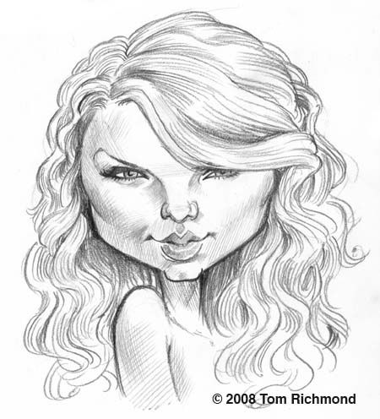
Who Am I? Write the name of the celebrity or the characters by the picture!

